Functional Test Record

SD card SPI bus and signal integrity
Configure an SD card to operate at fastest speed possible.

Procedure:
- Perform 1M R/W test,
  - Measure and record bus speed: __________
  - Capture and record transaction beginning end such that timing can be seen, record two captures here
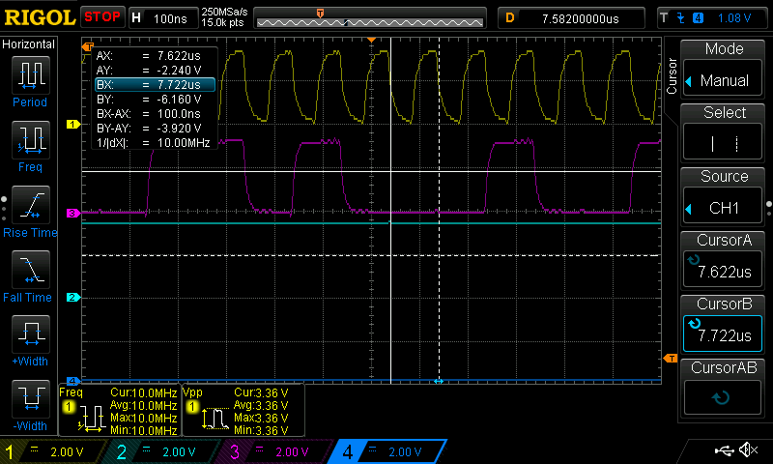
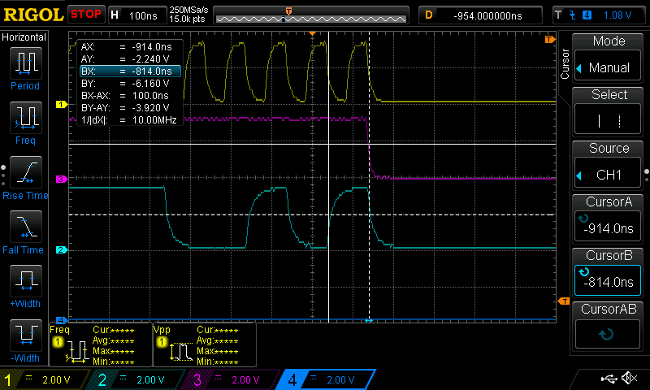
  - Load the bus with another device
  - Capture and record transaction beginning end such that timing can be seen, record two captures here
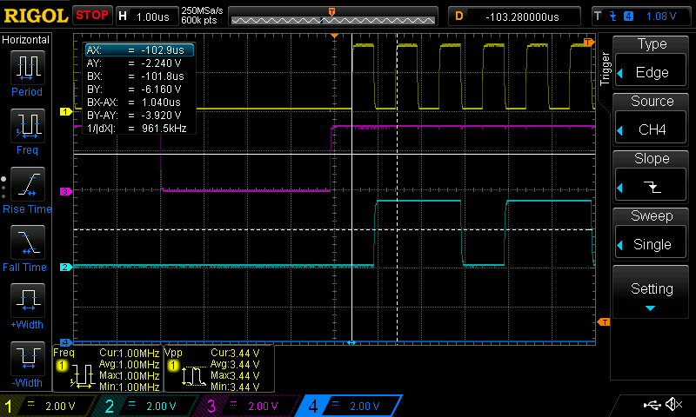
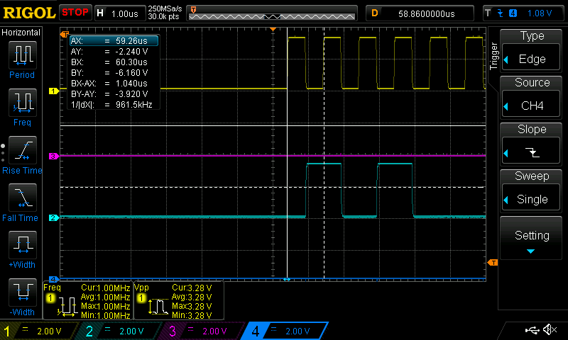

Criteria:
- Does the SD car work alone, and with multiple devices? YES, Same bus speed limitation (probably max 1MHz)
- Does the other device also work? YES
- Do signals have sufficient setup and hold times? YES
- Are signals monotonic? YES
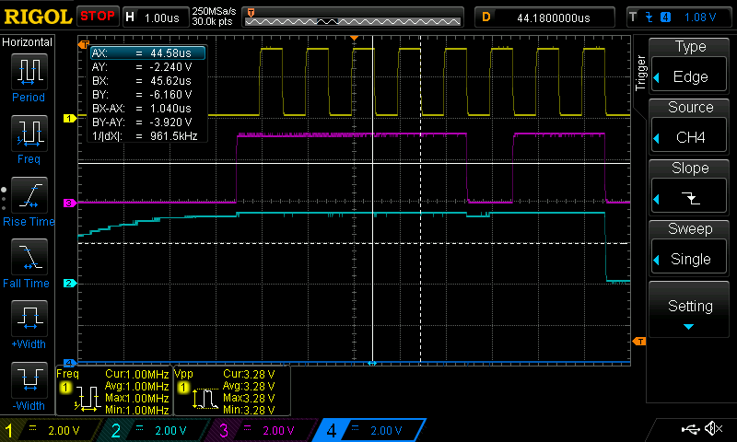
- Are signals monotonic? YES/NO

Check SD card CD function
Configure for SD card detection

Procedure:
- With no card inserted, measure voltage on detect pin_____
- With card inserted, measure voltage on detect pin_____
- Recored pin configuration necessary here:

Criteria:
- Do voltages fall outside ESP32 IO levels? NO – CD incorrectly wired, fixing in next rev

IMU
Configure the gyro and accelerometer for use and measure bus conditions. Make a program that continuously reads all 9 axes.

Peform the following during read loop:

Procedure:
- Measure and record bus speed: 100KHz
- Capture and record transaction beginning end such that timing can be seen, record two captures here
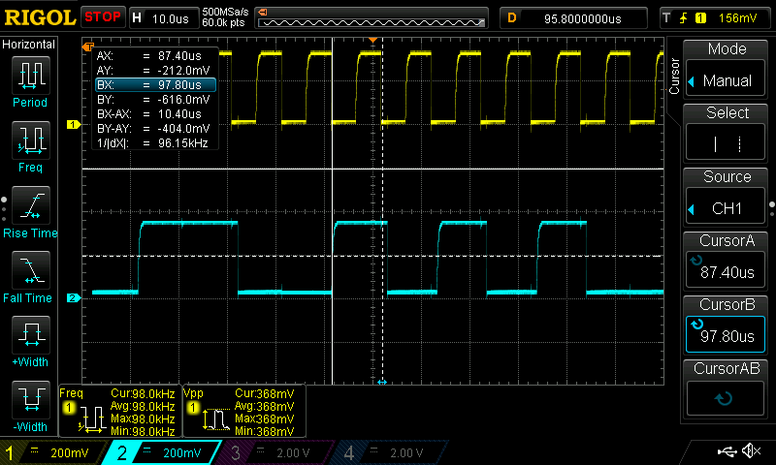
- Load the bus with another device
- Capture and record transaction beginning end such that timing can be seen, record two captures here

Criteria:
- Does the other device also work? YES
- Do signals have sufficient setup and hold times? YES
- Are signals monotonic? YES

Test IMU power features
Power switch has been scrapped

Test the GPS port
Check that the serial pass-through is working fine

Procedure:
- Loop-back the serial port
- Run a program to return usb serial commands through the port
- Capture a bit-variable character up to 115200 baud, measuring on the loopback
- Measure the symbol rate for 9600, 57600, and 115200
  - 9600: 9709, coming from cheap GPS, 9652 from loopback
  - 57600: 57800 from loopback
  - 115200: 115200 from loopback

Criteria:
- Do the symbols have good integrity up to 115200? YES
- Is the symbol rate correct? YES

Test GPS module functionality
Expose GPS modules to the sky and check features

Procedure:
- Attach 3 pin module.
- Power device and wait for lock, record: _____
- Record sample output:
- Attach 4 pin module to holes
- Power device and wait for lock, record: _____
- Record sample output:

Criteria:
- Does the cheap module work well? YES
- Does the expensive module work well? SKIPPED
- Is one module better than the other? YES/NO

Test board power rails
Check that nothing is behaving stragely

For these tests, all functions should be running at greatest load

Procedure:
- Measure ripple on power supply lines of shield: 7.6 mV p-p
- Attach current probe to isolate 3.3V rail
- Measure full load power draw: _____
- Switch board on and off
- Measure 3.3V rail rise time: 70uS
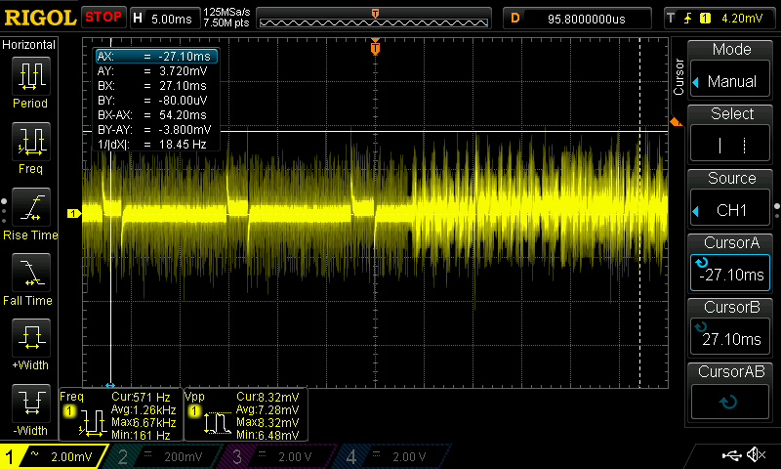
Criteria:
- Is the current draw acceptable for battery use? SKIPPED
- Is the rise time ok, > 10uS for IMU? YES
- Is the ripple acceptable? YES

